Introduction to Machine Learning - Homework 2
Elad Aspis 313597023 Tom Agami 302485628

Question 1:
We didn’t use validation set for data preparation. Validation set is designed to adjust best hyper parameters – which is belong to the learning process by lectures and not for preprocessing process.
We didn’t use validation set for data preparation. We should not interrupt the test data with the train and the validation data (we don’t want to make “overfitting” using hyper parameters by the test set).

Question 2:
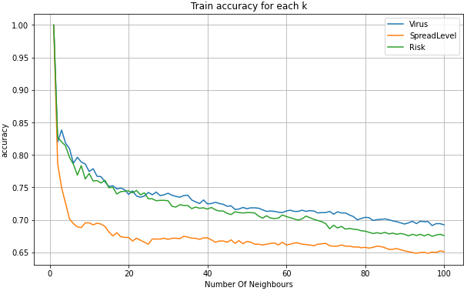
Plot of the train set accuracies:

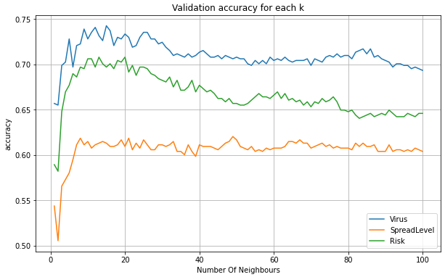
Plot of the validation set accuracies:

Question 3:

Train results :
$$K value$$ | $$Accuracy$$
$$1$$ | $$1$$ | $Virus$
$$1$$ | $$1$$ | $SpreadLevel$
$$1$$ | $$1$$ | $Risk$

Validation results :
$$K value$$ | $$Accuracy$$
$$15$$ | $$0.7427$$ | $Virus$
$$49$$ | $$0.620437$$ | $SpreadLevel$
$$13$$ | $$0.708$$ | $Risk$

Question 4:

$k$ is a parameter that refers to the number of nearest neighbours to include in the majority of the voting process in KNN algorithm.
A small value of $k$ could lead to overfitting because we rely on small number of nearest examples.
A big value of $k$ could lead to underfitting because we rely on big number of nearest examples.
Also, we can see in the training set graph that when $k$ is getting bigger the accuracy is decreasing.
It’s make sense because we make the algorithm more generalized and we refer to farther examples in each example.

Question 5:

$$K value$$
$$15$$ | $Virus$
$$11$$ | $SpreadLevel$
$$13$$ | $Risk$

We determine this by the accuracies of the validation set for each label to make it more generalized.
Unsurprisingly, the accuracy is 1 in each label.
Question 6:
(t is max depth tree)

Plot of the train set accuracies by decision tree:
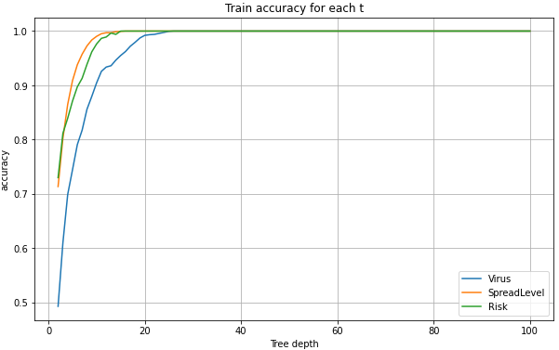

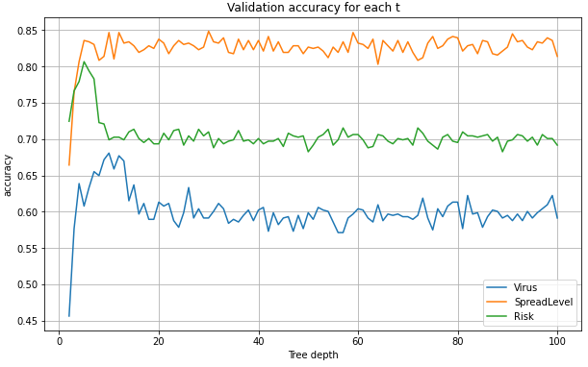
Plot of the validation set accuracies by decision tree:

Question 7:

Train results :
$$Maximal Depth value$$ | $$Accuracy$$
$$26$$ | $$1$$ | $Virus$
$$16$$ | $$1$$ | $SpreadLevel$
$$15$$ | $$1$$ | $Risk$

Validation results :
$$Maximal Depth value$$ | $$Accuracy$$
$$10$$ | $$0.6806$$ | $Virus$
$$30$$ | $$0.8485$$ | $SpreadLevel$
$$5$$ | $$0.8065$$ | $Risk$

Question 8:

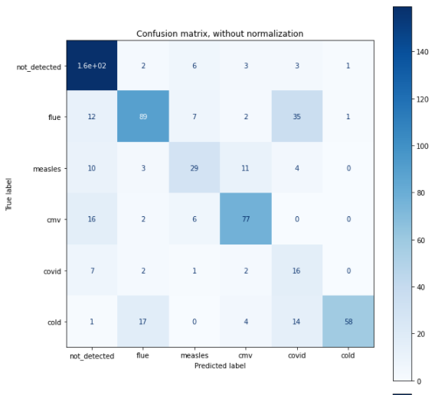

Question 9:
The 2 most important features are DisciplineScore and HouseholdExpenseOnSocialGames.
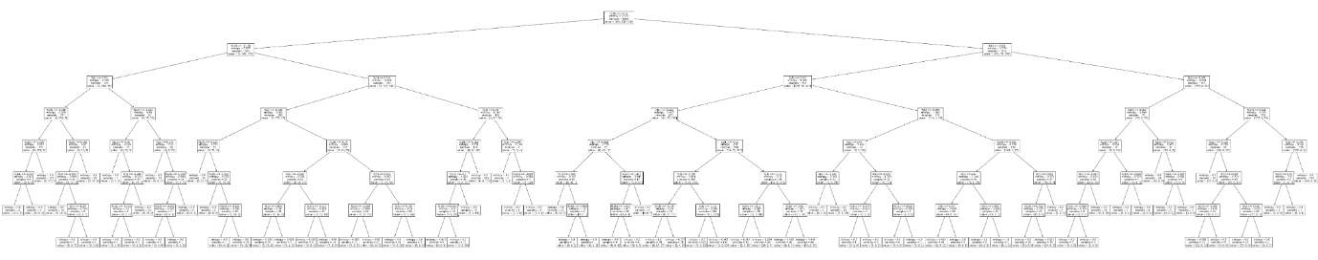
The Important features belong to the higher nodes of the tree in accordance the information gain computation. (JPEG Included)

Question 10:
Decision boundaries of the training set:

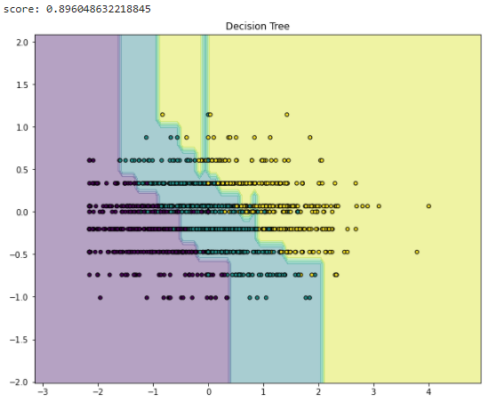

Decision boundaries of the validation set:
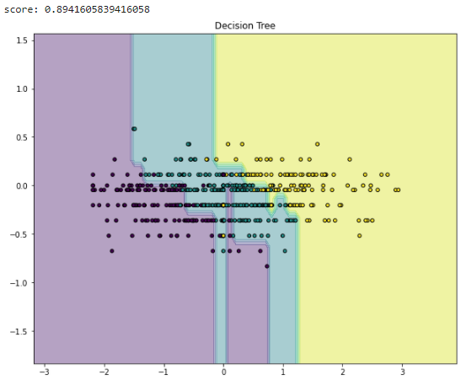

Question 11:
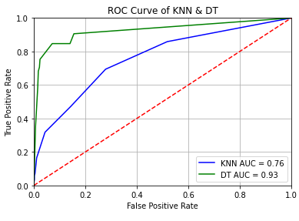

Question 12:
We don't want that a human with a high spread level detected as low (we want to prevent dangerous situation), hence we prefer to choose the “higher” line with the bigger precision, and that’s why we prefer DT model. We choose the 0.05 as a “good enough” (from this point the and quite low FP. The point with $Precision=\frac{TP}{TP+FP}$ is $\frac{0.84}{0.84+0.07}=0.92$ is a good point enough for us and from that point the precision is decreasing.

Question 13:
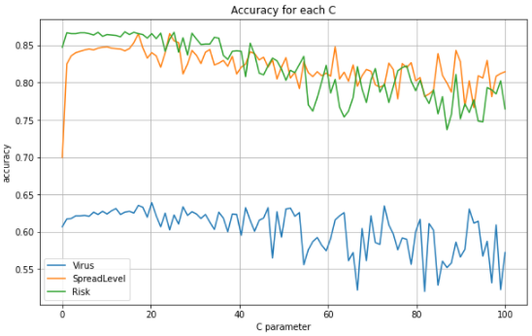
Plot of the train set accuracies by SVM:

Plot of the validation set accuracies by SVM:
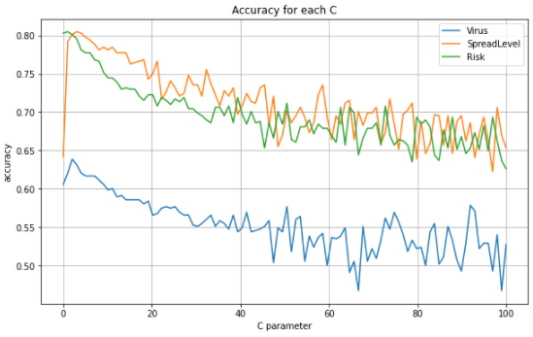

Question 14:

Train Results:
$$C value$$ | $$Accuracy$$
$$20.21$$ | $$0.656$$ | $Virus$
$$17.180$$ | $$0.865$$ | $SpreadLevel$
$$14.15$$ | $$0.868$$ | $Risk$

Validation Results:
$$C value$$ | $$Accuracy$$
$$2.03$$ | $$0.6386$$ | $Virus$
$$3.04$$ | $$0.8047$$ | $SpreadLevel$
$$1.02$$ | $$0.8047$$ | $Risk$

Question 15:
The best 5 features for recognize the flue are:
- PCR_17
- PCR_76
- PCR_9
- PCR_10
- PCR_95
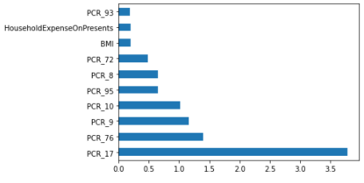

Question 16:
From the train graph we can see that we haven’t reach the 100% accuracy and hence we can conclude that the data isn’t lineary seperable.
Question 17:

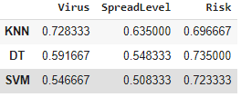

Question 18:

KNN is the best model for Virus and SpreadLevel labels on test set.
Decision Tree is the best model for Risk Label on test set.
KNN is the best model for Virus label on validation test.
Decision Tree is the best model for SpreadLevel and Risk labels on validation test.

If a model can performs well on the validation set but not on the test set we can say the generalization isn’t good enough.
In other words, it’s occurs when we overfitting model.

Question 19:
When we search for the best hyper parameters, we don't want to involve the test set because we can cause an overfitting by the hyper parameters.
All the decision about training weights, and the hyper parameters should be chosen without the testing dataset.
Actually, we want to test our model after all tuning parameters and etc.
If we’ll tune our model using the test set, we can without intention overfitting our test set and we don’t want to do that.

Question 20:
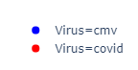
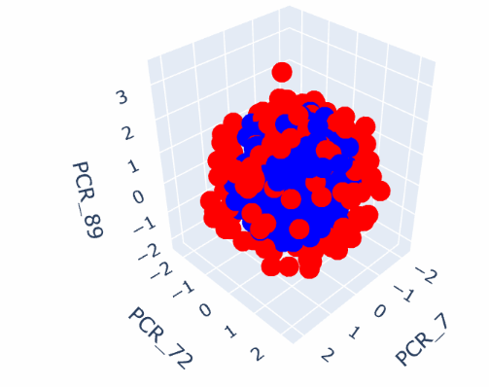
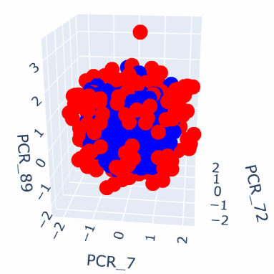

We can see that outside the sphere with $radius ≈1.5$ most of the examples with covid label, and inside the sphere most of the examples with cmv label.
Question 21:
We chose RBF kernel because we can by observing see that the data is seperable by sphere.

Question 22:
Plot of the train set accuracies as a function of the hyperparameters:
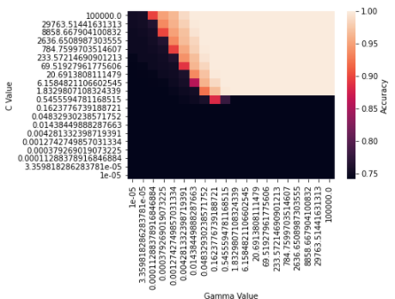

Plot of the validation set accuracies as a function of the hyperparameters:

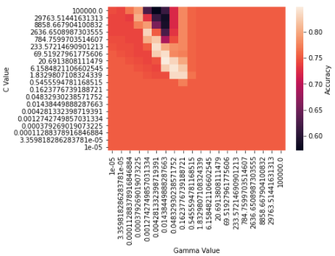
Question 23:

Train Results:
$$Gamma value$$ | $$C value$$ | $$Accuracy$$
$$0.16237$$ | $$233.572$$ | $$1$$

Validation Results:
$$Gamma value$$ | $$C value$$ | $$Accuracy$$
$$0.16237$$ | $$233.572$$ | $$0.77922$$

